PRACTICAL - 04
AIM : Run a java program based on parallel programming to implement the concept of Map Reduce.
[ Hadoop WordCount Execution Steps (Using PuTTY) ]

PROCEDURE :

Step 1: Prepare Input Data
echo "Hadoop is big data Hadoop is Java" > sample.txt hdfs dfs -mkdir /input hdfs dfs -put sample.txt /input/
hdfs dfs -ls /input

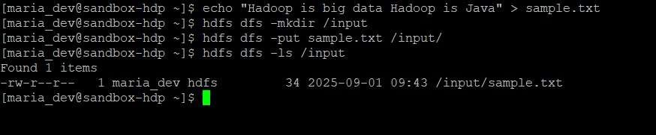

Step 2: Create Java Files :
Use commands :
- vi WordMapper.java
- vi WordReducer.java
- vi WordCountDriver.java

WordMapper.java
import java.io.IOException;
import org.apache.hadoop.io.IntWritable; import org.apache.hadoop.io.LongWritable; import org.apache.hadoop.io.Text; import org.apache.hadoop.mapreduce.Mapper;
public class WordMapper extends Mapper<LongWritable, Text, Text, IntWritable> { private final static IntWritable one = new IntWritable(1); private Text word = new Text();
public void map(LongWritable key, Text value, Context context) throws IOException,
InterruptedException {
String line = value.toString();
for (String token : line.split("\\s+")) { // Corrected escape sequence word.set(token);
context.write(word, one);
}
}
}

WordReducer.java
import java.io.IOException;
import org.apache.hadoop.io.IntWritable; import org.apache.hadoop.io.Text; import org.apache.hadoop.mapreduce.Reducer;
public class WordReducer extends Reducer<Text, IntWritable, Text, IntWritable> { public void reduce(Text key, Iterable<IntWritable> values, Context context) throws IOException, InterruptedException { int sum = 0;
for (IntWritable val : values) { sum += val.get();
}
context.write(key, new IntWritable(sum));
}
}

WordCountDriver.java
import org.apache.hadoop.conf.Configuration; import org.apache.hadoop.fs.Path; import org.apache.hadoop.io.IntWritable; import org.apache.hadoop.io.Text; import org.apache.hadoop.mapreduce.Job;
import org.apache.hadoop.mapreduce.lib.input.FileInputFormat; import org.apache.hadoop.mapreduce.lib.output.FileOutputFormat; public class WordCountDriver {
public static void main(String[] args) throws Exception { if (args.length != 2) {
System.err.println("Usage: WordCountDriver <input path> <output path>"); System.exit(-1);
}
Configuration conf = new Configuration(); Job job = Job.getInstance(conf, "word count"); job.setJarByClass(WordCountDriver.class); job.setMapperClass(WordMapper.class); job.setReducerClass(WordReducer.class); job.setOutputKeyClass(Text.class); job.setOutputValueClass(IntWritable.class);
FileInputFormat.addInputPath(job, new Path(args[0]));
FileOutputFormat.setOutputPath(job, new Path(args[1]));
System.exit(job.waitForCompletion(true) ? 0 : 1);
}
}

Step 3: Compile Java Files mkdir wordcount_classes hadoop com.sun.tools.javac.Main -d wordcount_classes WordMapper.java
WordReducer.java WordCountDriver.java
(If error, use:)
javac -cp `hadoop classpath` -d wordcount_classes WordMapper.java WordReducer.java WordCountDriver.java

Step 4: Create JAR
jar -cvf wordcount.jar -C wordcount_classes/ .

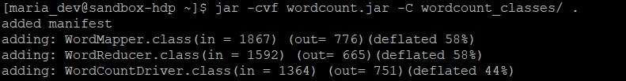

Step 5: Run MapReduce Job
hdfs dfs -rm -r /output
hadoop jar wordcount.jar WordCountDriver /input /output

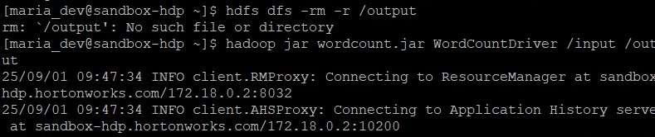

Step 6: View Output
hdfs dfs -ls /output

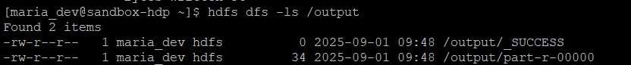

hdfs dfs -cat /output/part-r-00000

